Snippet of code I found interesting:

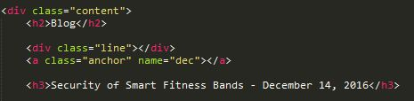

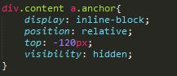

For the fixed header not to cover the first part of the blog post, a negative offset from the top had to be applied to the anchor in CSS. Otherwise, it would scroll down over the first part of the blog post.

Issues I encountered:

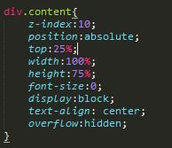

In the homepage, there was always a gap between the different divs that I could not get rid of. I tried everything until I remembered that we mentioned it briefly in class. So, I went on to w3schools to find the fix. Apparently html adds a whitespace character between the divs if they are not on the same line. The only way to fix that is to set the font-size to 0, so that the whitespace would disappear, and then set it back to the desired value inside the div.

Also, finding the right colors that match was a bit challenging. I had to keep asking my more art-inclined friends for help.

What I learned:

Honestly, most of what I learned was more about the design aspect of the project than coding. Finding background images that don’t obscure the text, choosing the right colors for paragraphs vs. sidebar items were all design challenges I had to deal with, which I think gave me a better design sense.

Future Steps:

I would like to implement Disqus to allow visitors to comment on my blog posts and tutorials.

I would also like to post Blog posts about javascripts applets I developed, and embed them in the website somehow.